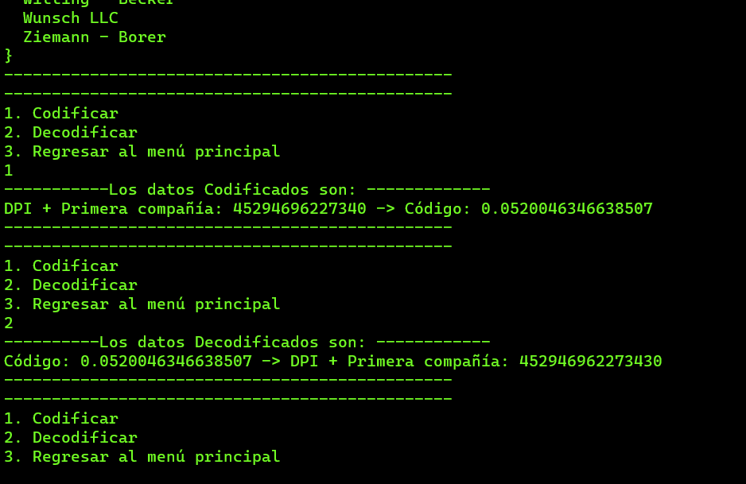

4529469622734

6347346469583

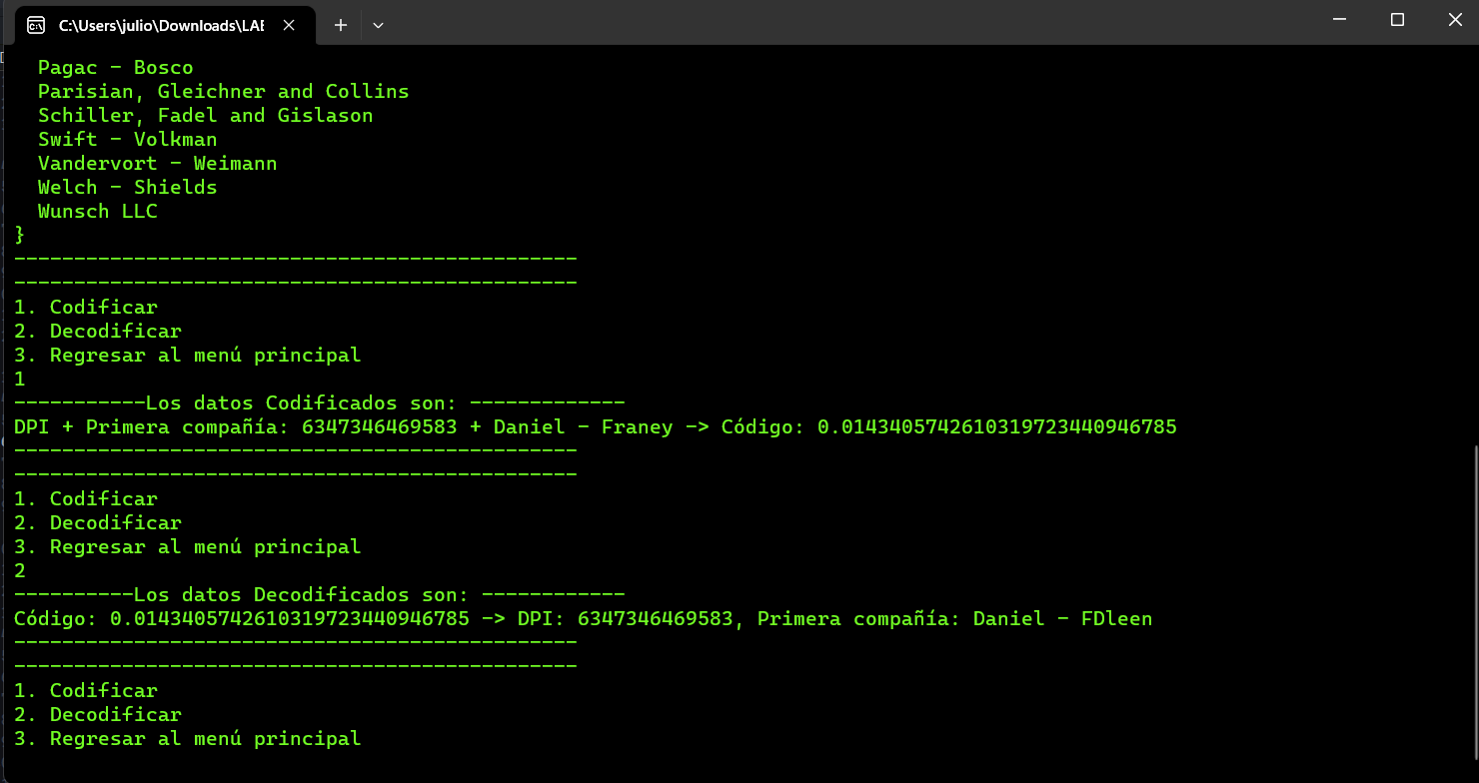

- Emard LLC

- Marvin - Legros

- Mertz, Casper and Hirthe

- Ziemann - Borer

- Kub and Sons

- Gottlieb - Sporer

- Conn - Huels

- Jones, Grady and Breitenberg

- Swift - Volkman

- Emard LLC

- Pollich and Sons

- Swift - Volkman

- Schuster, Olson and Doyle

- Pollich and Sons

- Lakin - Altenwerth

- Barrows and Sons

- Turner LLC

- Schuster, Olson and Doyle

- Pagac - Bosco

- Jones, Grady and Breitenberg

- Gaylord, Schiller and Murray

- Ziemann and Sons

- Turner LLC

- McDermott, Cummerata and Thompson

- Gottlieb - Sporer

- Vandervort - Weimann

- Gaylord, Schiller and Murray

- Mante - Lesch

- Jacobs - Farrell

- Jenkins – Douglas

7086098762013

